Software Quality Testing Interview
- How do you prioritize test cases under time constraints?
I prioritize test cases by focusing on Critical Functionality First, high-risk Areas, and frequently used features first to ensure maximum coverage in limited time.
🔹 Steps I follow:
- Critical Functionality First – Test features that are essential for the system to run (e.g., login, payment).
- High-Risk Areas – Focus on parts where defects could cause major failure or data loss.
- Frequently Used Features – Test areas that users interact with most often.
- Recent Changes or Fixes – Test modules affected by recent updates (for regression).
- Customer or Business Priority – Consider what matters most to clients or end users.
- Explain Boundary Value Analysis (BVA) and Equivalence Partitioning (EP) with examples.
1. Equivalence Partitioning (EP):
- It is a black-box testing technique where input data is divided into groups (partitions) that are expected to behave the same way.
- The idea is to test one value from each group instead of testing every possible input.
Example:
If an input field accepts 1 to 100,
then partitions are:
- Invalid: less than 1 (e.g., 0)
- Valid: between 1 and 100 (e.g., 50)
- Invalid: greater than 100 (e.g., 101)
So, you only test 0, 50, and 101 — not all values.
✅ Purpose: Reduces number of test cases while maintaining coverage.

2. Boundary Value Analysis (BVA):
- It focuses on testing values at the boundaries of input ranges since defects often occur there.
Example:
For input range 1 to 100, test:
- Lower boundary: 0, 1, 2
- Upper boundary: 99, 100, 101
✅ Purpose: Finds edge-case errors at limits of valid input.
- Difference between alpha and beta testing?
Feature | Alpha Testing | Beta Testing
Performed By | Internal team (developers + testers) | Real users (outside organization)
Environment | In a controlled lab environment | In real-world environment
Purpose | To identify bugs before release | To get user feedback and detect issues missed in alpha
Stage | Conducted before Beta testing | Conducted after Alpha testing (just before release)
Example | Company testers test an app internally | App is released to limited public for testing before official launch

- How do you handle a developer rejecting a bug?
💬 How to handle a developer rejecting a bug
- Recheck the bug:
First, verify the bug by reproducing it again with proper steps and data.
(Sometimes, the issue may not be consistent.)
- Provide strong evidence:
Share screenshots, logs, or video recordings to clearly show the bug.
- Refer to requirement documents:
If the developer still disagrees, refer to the requirement or design document to prove that the behavior is incorrect.
- Discuss professionally:
Have a polite discussion — the goal is to improve product quality, not win an argument.
- Involve lead if needed:
If the disagreement continues, escalate it to the QA lead or project manager for final decision.

- Have you used JIRA, TestRail, or HP ALM? How?
“I haven’t used JIRA, TestRail, or HP ALM directly, but I’m familiar with their purpose in the testing process.
JIRA is mainly used for bug tracking and task management, TestRail for writing and managing test cases, and HP ALM for end-to-end test planning and defect tracking.
I’ve read tutorials and understand the workflow, so I can quickly adapt and use these tools effectively in a real project.”

- What is ad-hoc testing vs. exploratory testing?
Aspect | Ad-Hoc Testing | Exploratory Testing
Definition | Ad-Hoc Testing is unplanned, random testing to quickly find bugs. | Manual testing where the tester simultaneously learns, designs, and executes tests.
Planning | No planning, no test cases. | Minimal planning; tester uses experience and intuition.
Focus | Quickly find defects in any part of the system. | Explore specific modules while discovering defects intelligently.
Documentation | Usually not documented. | Often partially documented (notes, observations).
Performed By | Testers or anyone with basic knowledge. | Skilled testers who understand the system.
Example | Randomly clicking buttons to see if something breaks. | Exploring the checkout flow of an e-commerce site, trying different inputs, edge cases, and combinations.

- Explain Severity vs. Priority in Defect Reporting
Aspect | Severity | Priority
Definition | Indicates how serious a defect is and its impact on the system. | Indicates how soon a defect should be fixed.
Focus | Technical impact on the application. | Business or customer urgency.
Determined By | Testers or QA team. | Product Owner, Project Manager, or Business team.
Example | Login button not working = High Severity. | Cosmetic typo on homepage = Low Priority.
Nature | Usually fixed based on severity, but may vary. | Fixed based on business need, may not be critical technically.
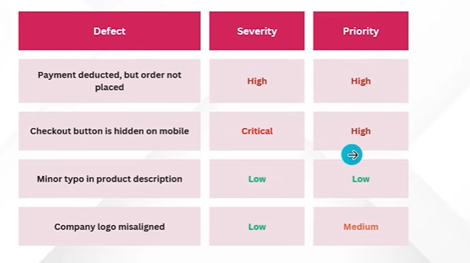
- What are non-functional testing types and their importance?

